**BOOKS NOW AVAILABLE at www.ifpress.com**

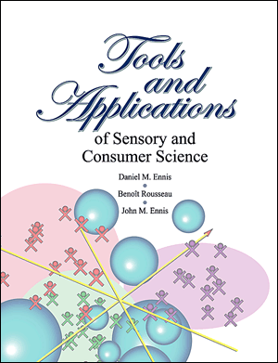

Drs. Daniel Ennis, Benoît Rousseau and John Ennis use their combined expertise to guide readers through pro-blems in areas such as:

* Drivers of Liking®
* Landscape Segmentation Analysis®
* Ratings & Rankings
* Claims Support
* Probabilistic Multidimensional Scaling
* Combinatorial Tools
* Difference Tests
* Optimizing Product Portfolios
* Designing Tests & Surveys

Visit our page at www.books.google.com to look inside and read a sample.

**Tools and Applications of Sensory and Consumer Science**

**55 Technical Report Scenarios Based on Real-life Problems**

Now in its fifth printing, this book is a must-have tool for professionals in product testing, consumer research, and advertising claims support. It con-tains our most significant and useful technical reports from the last 19 years. Readers will easily relate to the problems and solutions in each 2-page

scenario. And for deeper study, the reader will find a list of published papers on a variety of related subjects.

Also included are 27 tables for product testing methods so the reader can interpret results from discrimination methodologies such as the tetrad test, triangle test, same-different method, duo-trio test, replicated testing, and others.

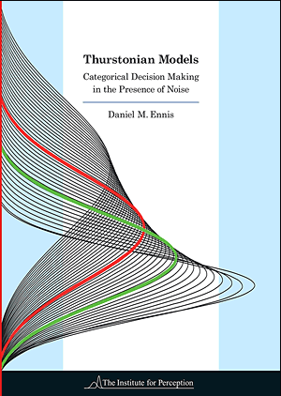

**Readings in   
Advertising Claims Substantiation**

**Eight chapters exploring three topics crucial   
to making defensible claims**

Among the important topics in supporting advertising claims, there are three that have needed attention for the last decade. These three topics are testing for equi-valence, testing for multiplicative claims, and accounting for no preference/ difference in product testing. After reading this book, practitioners will have a reliable

basis for making defensible and truthful advertising claims that can be backed up by competent science.

Dr. Daniel Ennis and Dr. John Ennis use their combined expertise to guide readers to develop a technical background in the three areas that support advertising claims substantiation. If you are involved in providing technical support for claims, or refuting those of your competitors, you will need to know what is in this book.

*94 pages, $95, plus shipping and 5.3% VA sales tax, where applicable.*

**Thurstonian Models   
Categorical Decision Making in   
the Presence of Noise**

Is it possible to develop a unifying theoretical framework for behavioral disciplines? Categorical decision making is ubiquitous as it arises in numerous disciplines such as eco-nomics, psychology, political science,

sensory and consumer science, mar-keting, and survey research. While reading this book, you will be provided a comprehensive account

of the derivation of Thurstonian models for a wide variety of behavioral tasks including preferential choice, ratings, triads, tetrads, dual pair, same-different and degree of difference, ranks, first-last choice, and applicability scoring.

Dr. Daniel Ennis presents the derivation of an interconnected theoretical structure based on Thurstonian ideas that link behavioral tasks together. This book is intended to be an essential reference for senior undergraduates and graduate students, academics and industrial professionals whose work and scientific curiosity lead them to consider how the outcome of choice tasks can be modeled.

*104 pages, $95, plus shipping and 5.3% VA sales tax, where applicable.*

*176 pages, $95, plus shipping and 5.3% VA sales tax, where applicable.*